**Key dispenser**

Create a tool for numeric keys distribution with a simple UI.

**Pre-requisites:**

2 or more text files, each containing sets of numeric strings



**Description:**

The tool dispense keys from text files.

The tool must contain an option to select the correct key batch using a drop-down list.

Keys that have been distributed must be removed from the text file to avoid giving a used key.

Additionally, the tool must store the information in a separate text file about each dispensed key and the user who took it in the following format:

[Key used] – [Windows Username] – [Time and Date]

*\*Example:* 894 473 519 647 – UserName1 - 2018-04-12 16:12:22

**User interface:**

* Drop-down list with the key batches names.
* Output text field;
* ‘Get Key’ button to output a key;
* ‘Cancel’ button to close the program;

*\*Example:*

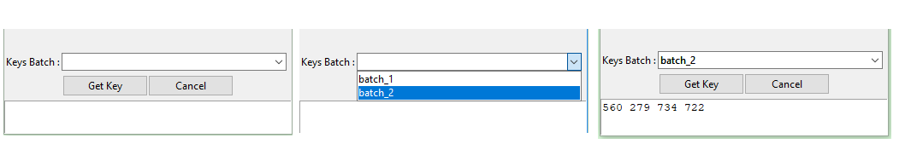

**Requirements**:

* Please provide your app as a standalone .exe converted from Python, as well as source .py script